Generating Service Now Tickets automatically using excel file data

Pre-requistics:

1. Service-now instance activated.
2. Github account (to store excel file)
3. Python and Ansible installed
4. Ready Yml file for generating ticket

Introduction:

Our task is to fetch the “start_date” and “short_description” field from the excel file which contains a list of them.

And then we need to generate service now tickets for each of the fields automatically without manually doing it.

This will be more efficient and fully automatic. No need of editing yml file or doing ansible scripting.

Procedure:

Step 1:

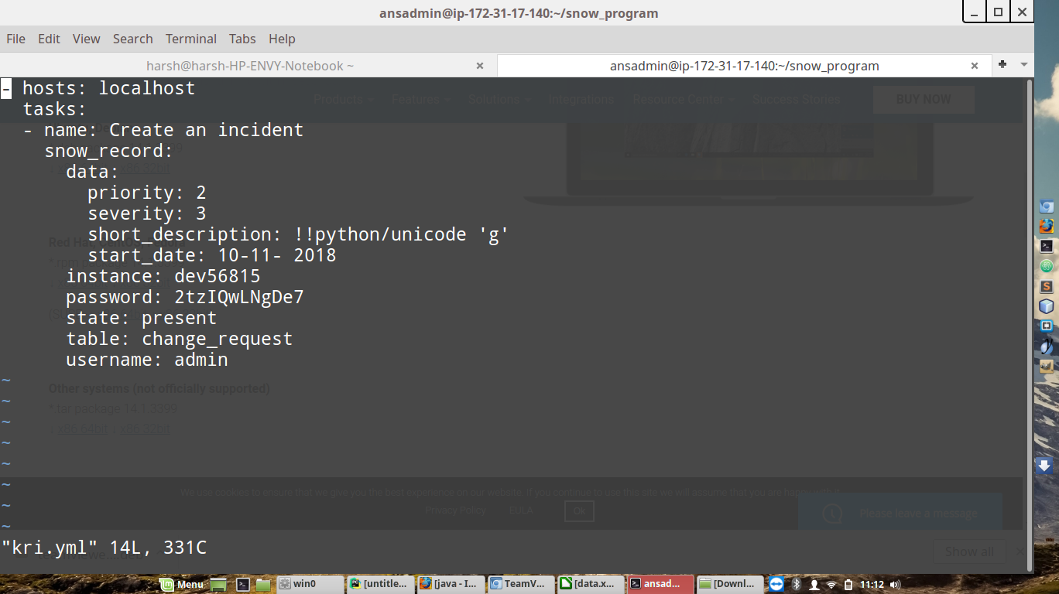

You can see the .Yml file which can generate the ticket.

“ Pay proper attention towards the indentation and syntaxes while creating the yml file as otherwise it gives error ”

Now the .Yml file contains the ‘start_date’ and ‘short_description’ field both of which are to be taken from the excel file.

Step 2:



This is the sample excel file we store in our github repository. Date is stored here only till 10 (can be extended till 30 or 31).

The letter that you see in the boxes are the short descriptions.

For example: in index 3B there is K; so when program will fetch the value , it fetches K as ‘short_description’ and 2 Jan as the ‘start_date’ (because it lies on 2 of date and Jan of month).

All these are the constraints that are to be followed because of the python program made that way. When you try to change anything , remember it should also reflect in the program( main.py)

So now , you have .yml file on the VPS instance or locally ; Excel file on Github repository ready.

Step 3:

Now we need to create main python program which integrates all and generates ticket automatically.

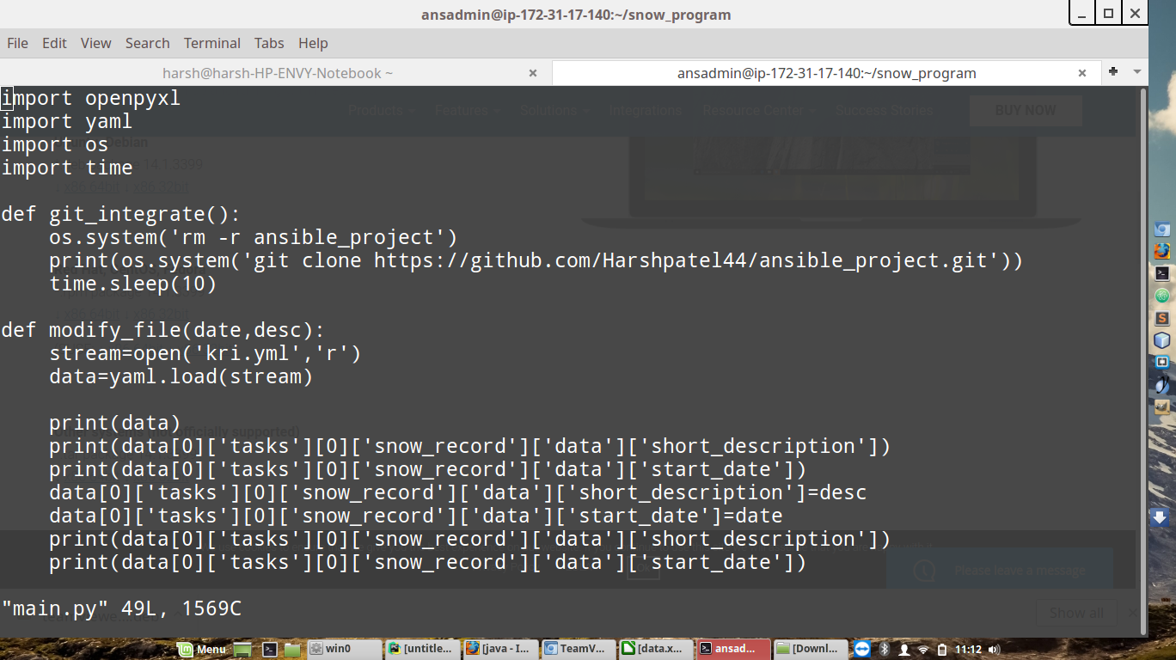

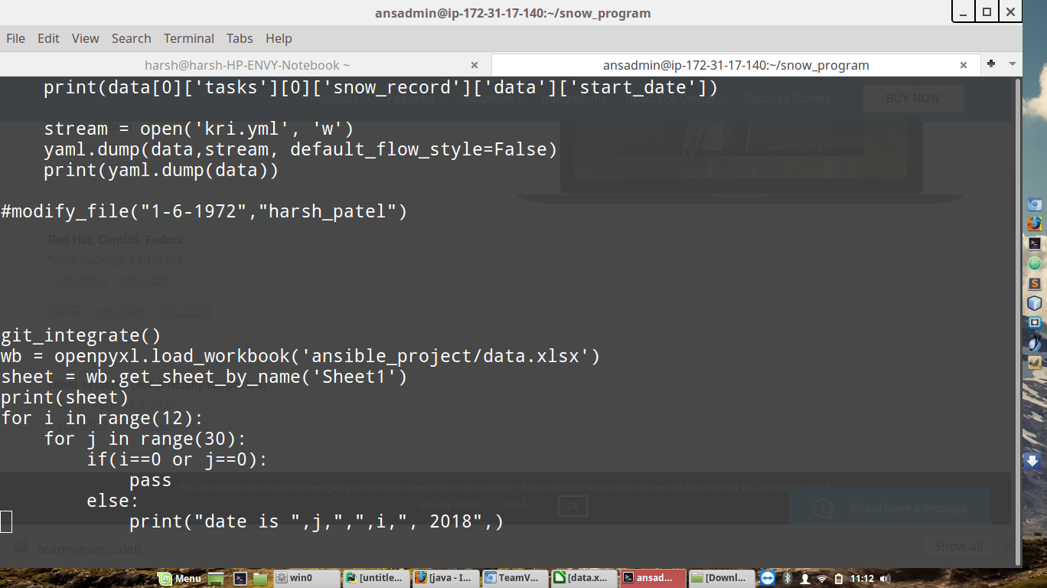

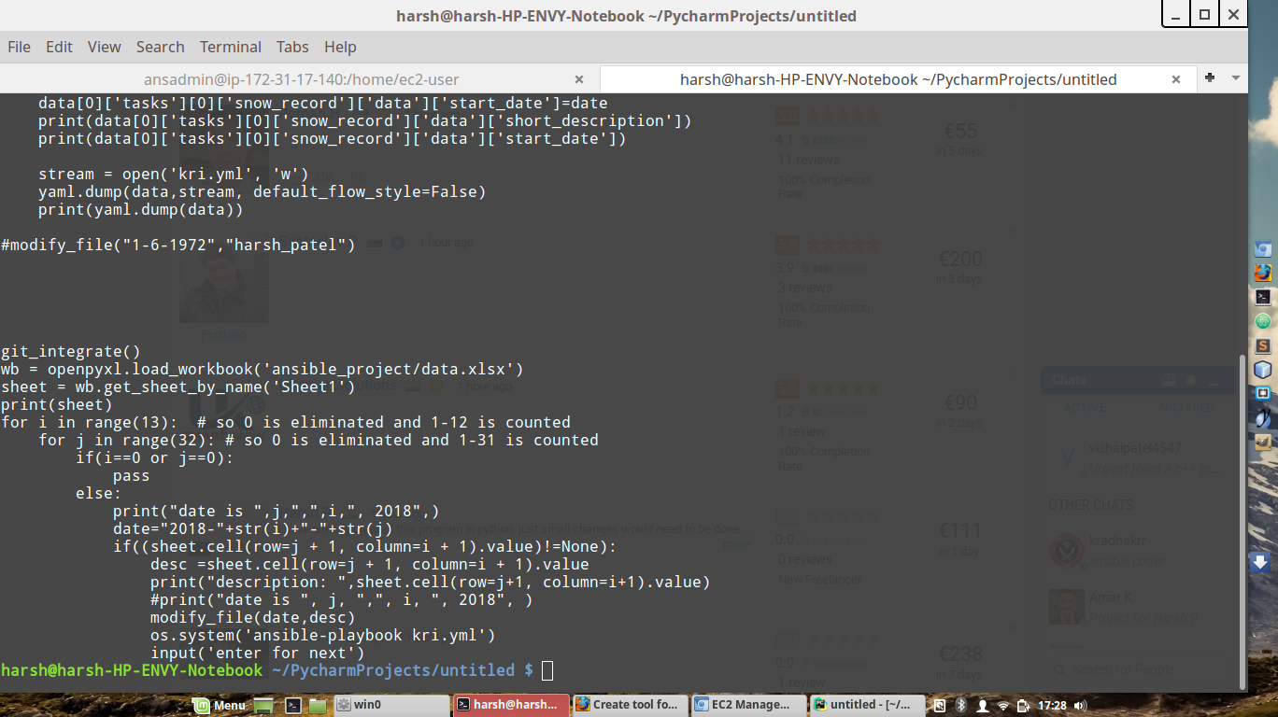



The modules used in the program are : openpyxl, yaml, os, time

To install any of the module in linux os, command is:

sudo apt-get install openpyxl

sudo apt-get install pyyaml

Firstly git_integrate() is the function which executes and clones the github repository to the machine. Hence now we have the excel file on our system.

Then openpyxl is used to open the excel file and fetch the ‘start_dates’ and ‘short_description’ of all the rows one by one.

Each time the value is fetched from the excel file, it is passed to modify_file() function.

Modify_file() opens the .yml file (shown in step 1 for creation of ticket) and puts the ‘start_date’ and ‘short_description’ value in it.

Finally ansible script command to create the ticket using the .yml is executed.

The command in the python program is os.system(‘ansible-script kri.yml’)

Kri.yml is the .yml file.

Step4:

So, Everything is setup and now we only need to run the python file i.e. main.py here.

All the tickets for the dates in the excel files will be generated and shown in the service now dashboard.

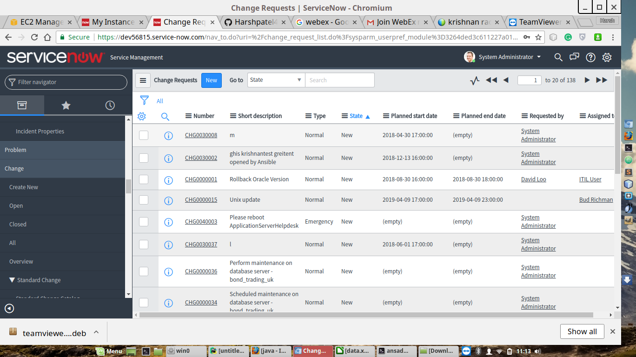

In this Screenshot above, you can see ‘m’ and ‘l ’ as the short_description which are executed by python script.

Thank You.